

**INNOVATE. CREATE. SOLVE**

Bengaluru, Karnataka, India

AN INTERNSHIP REPORT

ON

“Tribute To Doctors”

#### Bachelor of Engineering

#### In

#### Information Science and Engineering

#### 

#### Submitted by: Abhishek Prasad (1AY18IS006)

#### 

#### 

#### 

#### 

**ACHARYA INSTITUTE OF TECHNOLOGY**

#### 2021-2022

## ABOUT THE COMPANY

IC Solution (ICS) is a digital service provider that aims to provide software, designing and marketing solutions to individuals and businesses. At ICS, we believe that service and quality is the key to success

We provide all kinds of technological and designing solutions from Billing Software to Web Designs or any custom demand that you may have. Experience the service like none other!

Some of our services include:

Development - We develop responsive, functional and super-fast websites.

We keep User Experience in mind while creating websites. A website should load quickly and should be accessible even on a small view-port and slow internet connection.

Mobile Application - We offer a wide range of professional Android, iOS & Hybrid app development services for our global clients, from a start up to a large enterprise.

Design - We offer professional Graphic design, Brochure design & Logo design. We are experts in crafting visual content to convey the right message to the customers.

Consultancy - We are here to provide you with expert advice on your design and development requirement.

Videos - We create a polished professional video that impresses your audience.

**TABLE OF CONTENTS**

Table of contents ii

Overview of the Project 1

Tools Used 4

Implementation 3

Snapshots 22

Bibliography 32

About my Team 33

## OVERVIEW OF THE PROJECT

## Project Name: Tribute to Doctors

**Team Members:** **Abhishek Prasad 1AY18IS006**

## This project is based on Web Development And its Applications. The main objective of this project is to learn the implementation of HTML, CSS and JavaScript. The basic webpage of this project is created using HTML and styling of the webpage is done using CSS.

## This webpage is about TRIBUTE TO DOCTORS for serving the nation and risking their lives in national emergency due to pandemic COVID-19.

## The webiste has the information of the doctors who have lost their lves in second wave of covid. The website also contains the data of cases of covid.

# TOOLS USED

### Software Requirements

* Visual Studio Code 2019.
* Google Chrome or Microsoft Edge of latest version.
* Front End: HTML, CSS, JS (optional)
* Linux 7.1 or Windows XP/7/8/10 OS or Mac OS

### Hardware Requirements

* Pentium 200-MHz computer with a minimum of 64 MB of RAM (128 MB of RAM recommended).
* Monitor with a refresh rate of at least 40Hz for a smooth GUI experience (optional).

# IMPLEMENTATION

# Source Code (P1.HTML):

# Tribute.html

<!DOCTYPE html>

<html>

<head>

  <meta charset="UTF-8">

  <meta name="viewport" content="width=device-width, initial-scale=1.0">

  <title>Tribute to Doctors</title>

  <link rel="stylesheet" href="style.css">

</head>

<body style="background-color:rgb(236, 226, 164);">

  <nav>

    <ul>

      <li><a href="Tribute.html">Home</a></li>

      <li><a href="https://www.mohfw.gov.in/pdf/coronvavirushelplinenumber.pdf" target="_blank">Covid Helpline</a></li>

      <li><a href="vid.html">Second Wave News</a></li>

      <li><a href="video.html">Tribute Video</a></li>

      <li><a href="Articles.html" target="_blank">News Articles</a></li>

      <li><a href="https://www.arcgis.com/apps/dashboards/bda7594740fd40299423467b48e9ecf6">Covid-19 Graph</a></li>

      <li><a href="copyright.html">Copyright ©</a></li>

    </ul>

  </nav>

  <header>

  <img id="logo" src="logo.png" alt="logo" width="150px" height="150px">

  <img id="logo1" src="logo.png" alt="logo" width="150px" height="150px">

    <h1><u>Tribute to Doctors</u></h1>

  </header>

  <blockquote>“A doctor, like anyone else who has to deal with human beings, each of them unique, cannot be a scientist; he is either, like the surgeon, a craftsman, or, like the physician and the psychologist, an artist. This means that in order to be a good doctor a man must also have a good character, that is to say, whatever weaknesses and foibles he may have, he must love his fellow human beings in the concrete and desire their good before his own.” — W. H. Auden<span id="docgif"><img id="gifimg" src="docgif.gif" style="width:270px;height:178px;"></span></blockquote>

  <section id="main">

   <figure id="img-div">

      <img src="doc.jpg" id="image" >

    </figure>

  </section>

  <section id="About">

    <p id="pgh1"><b>The 2019–2020 coronavirus pandemic is upending life on a global level as we know it. The highly infectious coronavirus disease 2019 (COVID-19) is caused by <u>severe acute respiratory syndrome coronavirus 2 (SARS-CoV-2)</u>.<br></br> It was first seen in Wuhan, Hubei, China where its outbreak was first identified in December 2019. After almost 3 months, on March 11, 2020, the World Health Organization recognized it as a pandemic considering its significant ongoing spread in multiple countries across the world.

      As of September 10, 2021, approximately 21.9 crore cases of COVID-19 have been confirmed worldwide in many countries and territories resulting in around 45.5 lakhs deaths. Clearly, the corona virus outbreak situation cannot be taken lightly. Global pandemic of COVID 19, its ophthalmic implications, and precautions are nicely summarized in recently published editorial.

      <br></br>While on one hand people across India and around the globe are largely confined to their homes with businesses and educational institutions all shut down in an attempt to contain the virus, and on the other hand doctors, health-care workers, and medical staff members are leading the battle against COVID-19 from the front. Putting their own lives at risk with selfless determination for the sake of saving lives, they truly are our heroes in these challenging times. While they are putting their own health, families, and most importantly their own lives at risk, the least we can do is appreciate their efforts and cooperate by staying safe indoors. That being said, it is good to see tributes pouring in for all the medical heroes working in scrubs.</b></p>

      <section id="worker-img">

        <img src="health-care.jpg" style="border: 5px solid #555;"/>

      </section>

      <h1 id="head2"><u>Health-care Workers and Fight against COVID-19</u></h1>

        <p id="pgh2"><b>Needless to say, doctors, nurses and people working in health-care sectors are particularly vulnerable to the highly infectious disease. In response to the global pandemic, the under-resourced doctors are facing unprecedented challenges. The list of the sleep-deprived heroes includes doctors, nurses, medical cleaners, pathologists, paramedics, ambulance drivers, and health-care administrators.<br></br>

          In the fight against coronavirus, the brave medical army stands strong with thermometers, stethoscopes, and ventilators as their weapons. Not to forget, medical researchers are working day in and night out against all odds, hoping to find the antidote to the disease.

          Since the coronavirus outbreak, health-care professionals have not only experienced the gratification of healing patients and saving their lives but have also lost many battles along the way. On top of that, many doctors have even sacrificed their own lives in the line of duty.

          Every day, the selfless warriors are giving it their all in health-care settings while cutting themselves off from their families and loved ones. The sacrifice that they are making for the safety and welfare of humanity is priceless and deserves lifelong gratitude on our end. Most importantly, we must reassess the value health-care workers hold in our lives and the kind of treatment they get from us.<br></br> Among the several lessons this coronavirus pandemic has been teaching us, the biggest one is to find ways to sufficiently invest in the better and more efficient medical fraternity and give medical professionals the respect, compensation and infrastructure that they truly deserve once this crisis is over. Moreover, the world needs to work towards advancement in medical research and technology. Nothing will be a greater tribute to the health-care workers than this.

          That being said, we'd now like to highlight the heroic efforts of some courageous and inspiring doctors from across the globe who lost their lives while saving the lives of COVID-19 patients.</br></b></p>

  </section>

  <section id="worker-img">

    <img src="vaccine.jpg" style="border: 5px solid #555;" width="750px" height="450px"/>

  </section>

  <section id ="Second-Wave">

    <h1 id="second-wave"><u>Challenges faced during second wave</u></h1>

        <p id="pgh3">Covid pandemic has made the healthcare system difficult to prepare for the situation. Ever since the second wave of the pandemic started, the healthcare system in India has been teetering on the brink, with many hospitals unable to handle the relentless inflow of patients whilst also running short of beds, oxygen cylinders and other essentials.<br></br>

          As the second wave crashed into 12 states across the country, medical health experts began tracking an aggressive new strain of virus that hit the lungs, almost immediately, on the first day of the infection. Shortness of breath was the defining medical symptom of the second wave.

          The EMS department at our hospital, which has a capacity of 5 beds, has been handling over 20 patients, at any given point of time, in the second wave. We are forced to turn away many patients. The first wave of the pandemic pales in comparison.

          It is definitely worse than last year. It's not a second wave but it feels like Covid tsunami had begun to loom over the horizon. It feels as people were dropping their guards assuming that the worst was behind them, India was hit by a second wave of the pandemic, the magnitude of which is rendering its already precarious healthcare system more overburdened than ever.<br></br> India has been reporting over two lakh cases a day in month of April and May, making it one of the worst Covid-affected countries in the world.

          Arrowing accounts of overburdened hospitals, people scrambling to secure oxygen supplies and medicines such as Remdesevir and  Actemra, morgues piling up with bodies, and funeral pyres flickering away late into the night amid soaring deaths.

          The new strain of the virus amid the second wave is more virulent and infectious, which leaves younger and healthy people in critical conditions as compared to before, they are gasping for breathe. And the lung involvement is like really, really high. We are seeing people in the 25-30 age groups dying.

          There was shortage of enough doctors or healthcare workers, especially given the spike in coronavirus cases, adding that this is also having repercussions on those patients with other critical illnesses as they face inordinate delays in getting treated.

          The shortage of supplies is also definitely a drawback.<br></br> In the First wave last year we were shortage of PPE and in the second wave working in the hospital, seeing more deaths, seeing the shortage of supplies and the hunt for medications by hospital and patient relatives - all this is definitely something that's creating a horrifying situation for all of us.

          All healthcare workers want to work, we have no problem in giving our services to deal with this virus and fight against the pandemic.

        </p>

  </section>

  <section id="worker-img">

    <img src="death.jpg" style="border: 5px solid #555;" width="750px" height="450px"/>

  </section>

  <section id="Lives-lost">

    <h1 id="life"><u>Doctors who Lost their Lives during 2nd Wave</u></h1>

      <p id="pgh4">Amidst the prevalence of the Covid-19 pandemic, the Indian Medical Association on Tuesday said that 798 doctors died during the second wave of Covid-19 across the country of which maximum 128 doctors lost their lives in Delhi, followed by Bihar at 115.<br></br>

            As per the official note by the IMA, the number of doctors who lost their lives in the pandemic in Delhi stands at 128, followed by Bihar at 115 and Uttar Pradesh at 79.

            States like Maharashtra and Kerala where the prevalence of the Delta Plus variant of Covid-19 is on a rise also reported deaths of doctors in double digits. Maharashtra reported 23 doctor deaths and Kerala reported 24 deaths.<br></br>

            Pondicherry reported the lowest deaths of doctors by logging one death only. Hours after Prime Minister Narendra Modi on Sunday praised doctors for going out of their way to extend help to people during the coronavirus pandemic, IMA President Dr JA Jayalal said that the PM has assured that doctors will be respected, protected and safeguarded.<br></br>

            Like every year, the country celebrated National Doctors' Day on July 1 to honour the contributions of the doctors. The first National Doctor's day was celebrated in the country in July 1991.<br></br>

            "PM Modi ensured that doctors should be respected, protected and safeguarded. He also emphasised the need for vaccination. We're celebrating this year's National Doctors' Day (July 1) in remembrance of the veteran Dr BC Roy. We're so much pleased that PM Modi greeted the medical fraternity for the Doctors' Day," the IMA President had said.<br></br>

            On June 25, the Indian Medical Association (IMA) informed that 776 doctors lost their lives in the second wave of Covid. According to the IMA Covid registry on June 25---in the state-wise doctors martyrs list, Bihar saw the maximum number of 115 deaths, followed by Delhi at 109, Uttar Pradesh 79, West Bengal 62, Rajasthan 44, Jharkhand 39, and Andhra Pradesh 40.<br></br>

            Meanwhile, India on Tuesday reported 37,566 fresh Covid-19 cases, the first time in 102 days that daily cases dropped below the 40,000 mark, the Union health ministry informed. With this, the country's total Covid-19 tally stands at 3,03,16,897, including 2,93,66,601 recoveries and 5,52,659 active cases.<br></br><br></br>

           <u style="font-size: 40px;">Some articles for reference:</u>

             <ul id="article-link">

               <li><a class="link" href="https://www.ndtv.com/india-news/coronavirus-730-doctors-died-due-to-covid-during-second-wave-indian-medical-association-bihar-maximum-fatalities-2465496">https://www.ndtv.com/india-news/coronavirus-730-doctors-died-due-to-covid-during-second-wave-indian-medical-association-bihar-maximum-fatalities-2465496</a></li>

               <li><a class="link" href="https://www.indiatoday.in/coronavirus-outbreak/story/624-doctors-died-due-to-covid-19-in-second-wave-ima-1810648-2021-06-04">https://www.indiatoday.in/coronavirus-outbreak/story/624-doctors-died-due-to-covid-19-in-second-wave-ima-1810648-2021-06-04</a></li>

               <li><a class="link" href="https://www.hindustantimes.com/india-news/nearly-600-doctors-died-of-covid-19-in-india-s-deadly-second-wave-101622657106876.html">https://www.hindustantimes.com/india-news/nearly-600-doctors-died-of-covid-19-in-india-s-deadly-second-wave-101622657106876.html</a></li>

               <li><a class="link" href="https://www.livemint.com/news/india/766-doctors-died-of-covid-in-second-wave-ima-data-11624618275646.html">https://www.livemint.com/news/india/766-doctors-died-of-covid-in-second-wave-ima-data-11624618275646.html</a></li>

               <li><a class="link" href="https://indianexpress.com/article/india/ima-flags-800-doctor-deaths-in-second-wave-7383639/">https://indianexpress.com/article/india/ima-flags-800-doctor-deaths-in-second-wave-7383639/</a></li>

  </section>

  <iframe width="700" height="450" src="https://www.youtube.com/embed/2EzGqMggfLo" frameborder="0" allow="accelerometer; autoplay; clipboard-write; encrypted-media; gyroscope; picture-in-picture" allowfullscreen></iframe>

  <footer>

    <p> <b> All Rights Reserved &copy; Abhishek Prasad & Aaraaf Mufti</b></p>

</footer>

  </body>

  </html>

# Articles.html

<!DOCTYPE html>

<html>

<head>

  <meta charset="UTF-8">

  <meta name="viewport" content="width=device-width, initial-scale=1.0">

  <title>News Articles</title>

</head>

<header>

<h1 id="article"><u>News Articles on Covid 2nd Wave</u></h1>

</header>

<body style="background-image: url('bk-img.jpg');">

</div>

<a href="Tribute.html" class="back-button" style="text-decoration: none;font-weight: bold;">

            <i class="icon-back">

                &#8617;

            </i>

        </a>

    </div>

    <ul>

      <li><a class="link" href="https://timesofindia.indiatimes.com/india/explained-why-india-is-witnessing-thick-tail-of-second-covid-wave/articleshow/85330404.cms">Times Of India</a></li>

      <li><a class="link" href="https://indianexpress.com/article/explained/explained-whats-changed-in-second-wave-7289002/">The Indian Express</a></li>

      <li><a class="link" href="https://economictimes.indiatimes.com/topic/covid-19-second-wave">Economic Times</a></li>

      <li><a class="link" href="https://www.bbc.com/news/world-asia-india-57225922">BBC News</a></li>

      <li><a class="link" href="https://www.thehindu.com/news/national/telangana/second-wave-of-covid-19-spreading-quickly/article34345120.ece">The Hindu</a></li>

    </ul>

    <style>

        body ul li a{

            color: rgb(45, 37, 95);

            text-decoration: none;

            font-weight: bold;

            font-size: 30px;

            font-family: -apple-system, BlinkMacSystemFont, 'Segoe UI', Roboto, Oxygen, Ubuntu, Cantarell, 'Open Sans', 'Helvetica Neue', sans-serif;

        }

        body ul {

            display: table;

            margin: 0 auto;

        }

        header{

            display: flex;

            justify-content: center;

            align-items: center;

            min-height: 200px;

        }

        header h1 {

            font-size: 5em;

            font-weight: bolder;

            color: rgb(53, 68, 138);

        }

        .back-button {

            position: absolute;

            left: 16px;

            top: 16px;

            font-size: 32px;

            z-index: 10;

            color: rgb(20, 20, 20);

        }

        .link{

            color:  rgb(45, 37, 95);

        }

        .link:hover{

            color: burlywood;

            text-decoration: underline;

        }

    </style>

    </body>

    </html>

# video.html

<!DOCTYPE html>

<html lang="en">

<head>

    <meta charset="UTF-8">

    <meta name="viewport" content="width=device-width, initial-scale=1.0">

    <title>👨‍⚕️Tribute Music Video</title>

</head>

<h1>👨‍⚕️<u>Tribute Music Video</u>👩‍⚕️</h1>

<body style="background-color:rgb(136, 13, 54);">

<video controls autoplay width="100%" height="640" >

  <source src="Tribute Video.mp4" type="video/mp4">

</video>

<style>

  h1{

    font-size: 40px;

    font-weight: bolder;

    text-align: center;

    color: blanchedalmond;

  }

</style>

</body>

</html>

# vid.html

<!DOCTYPE html>

<html>

<body style="background-color:rgb(46, 24, 24);">

    <head>

        <meta charset="UTF-8">

        <title>Second Wave News</title>

      </head>

<iframe width="490" height="345" src="https://www.youtube.com/embed/7_Dyxx0Dxno" frameborder="0" allow="accelerometer; autoplay; clipboard-write; encrypted-media; gyroscope; picture-in-picture" allowfullscreen></iframe>

<iframe width="490" height="345" src="https://www.youtube.com/embed/RLiP-uehAac" frameborder="0" allow="accelerometer; autoplay; clipboard-write; encrypted-media; gyroscope; picture-in-picture" allowfullscreen></iframe>

<iframe width="490" height="345" src="https://www.youtube.com/embed/oEcEwTsGoeU" frameborder="0" allow="accelerometer; autoplay; clipboard-write; encrypted-media; gyroscope; picture-in-picture" allowfullscreen></iframe>

<iframe width="490" height="345" src="https://www.youtube.com/embed/NhXPETkR2rI" frameborder="0" allow="accelerometer; autoplay; clipboard-write; encrypted-media; gyroscope; picture-in-picture" allowfullscreen></iframe>

<iframe width="490" height="345" src="https://www.youtube.com/embed/PnTC49uBRqU" frameborder="0" allow="accelerometer; autoplay; clipboard-write; encrypted-media; gyroscope; picture-in-picture" allowfullscreen></iframe>

<iframe width="490" height="345" src="https://www.youtube.com/embed/myb8GxLLpT0" frameborder="0" allow="accelerometer; autoplay; clipboard-write; encrypted-media; gyroscope; picture-in-picture" allowfullscreen></iframe>

<iframe width="490" height="345" src="https://www.youtube.com/embed/A85TW0g55Mo" frameborder="0" allow="accelerometer; autoplay; clipboard-write; encrypted-media; gyroscope; picture-in-picture" allowfullscreen></iframe>

<iframe width="490" height="345" src="https://www.youtube.com/embed/Sks_G1LOkrY" frameborder="0" allow="accelerometer; autoplay; clipboard-write; encrypted-media; gyroscope; picture-in-picture" allowfullscreen></iframe>

<iframe width="490" height="345" src="https://www.youtube.com/embed/89JZBQW7pwQ" frameborder="0" allow="accelerometer; autoplay; clipboard-write; encrypted-media; gyroscope; picture-in-picture" allowfullscreen></iframe>

</body>

</html>

# copyright.html

<!DOCTYPE html>

<html lang="en">

<head>

    <meta charset="UTF-8">

    <meta name="viewport" content="width=device-width, initial-scale=1.0">

    <title>Copyright</title>

    <link rel="stylesheet" href="copyright.css">

</head>

<body>

    <div class="split left">

        <div class="centered">

          <img src="Abhishek.jpg" alt="Avatar man">

          <h2>Abhishek Prasad</h2>

          <p>Email: abhishekm.18.beis@acharya.ac.in</p>

          <p><a href ="mailto:abhishekm.18.beis@acharya.ac.in">Send Email</a></p>

        </div>

      </div>

      <div class="split right">

        <div class="centered">

          <img src="aaraaf.jpg" alt="Avatar woman">

          <h2>Aaraaf Mufti</h2>

          <p>Email: aaraafm.18.beis@acharya.ac.in</p>

          <p><a href ="mailto:aarafm.18.beis@acharya.ac.in">Send Email</a></p>

        </div>

      </div>

</body>

</html>

# IMPLEMENTATION

# Source Code (P1.CSS+P1.JS(if used)):

# style.css

body{

    margin: 100;

    padding: 0;

    background-image:url('bk-img.jpg');

}

/* .h1{

    text-align: left;

    margin-left: 10;

    margin-top: 20;

    font-size:150%;

    position: relative;

    top: 100px;

} */

nav {

    position: fixed;

    top: 0;

    left: 0;

    background-color: rgb(0, 0, 0);

    width: 100%;

    z-index: 10;

  }

  nav ul {

    display: flex;

    justify-content: center;

  }

  nav ul li {

    margin: 0 20px;

  }

  nav ul li a {

    color: white;

    text-decoration: none;

    font-weight: bold;

    font-size: 18px;

    font-family: -apple-system, BlinkMacSystemFont, 'Segoe UI', Roboto, Oxygen, Ubuntu, Cantarell, 'Open Sans', 'Helvetica Neue', sans-serif;

  }

  nav ul li a:hover {

    text-decoration: underline;

  }

  main {

    text-align: center;

    max-width: 800px;

    margin: 0 auto;

  }

  header{

      display: flex;

      justify-content: center;

      align-items: center;

      min-height: 200px;

  }

  header h1 {

      font-size: 5em;

      font-weight: bolder;

      color: rgb(175, 6, 6);

  }

  #img-div {

    background-color: rgb(250, 250, 250);

    border: 5px solid #555;

    width: auto;

    height: 10%;

  }

  #image {

    max-width: 50%;

    display: block;

    display: block;

    margin-left: auto;

    margin-right: auto;

    width: 100%;

  }

  * {

    box-sizing: border-box;

  }

  #pgh1{

    padding: 50px;

    display: block;

    display: block;

    margin-left: auto;

    margin-right: auto;

    max-width: 100%;

    font-size: 20px;

    font-style:italic;

    color: rgb(5, 87, 102);

    font-weight: bolder;

  }

  #pgh2{

    width: 93%;

    display: block;

    display: block;

    margin-left: auto;

    margin-right: auto;

    max-width: 100%;

    font-size: 20px;

    font-style: inherit;

    color: rgb(5, 87, 102);

  }

  #head2{

    font-size: 3.2em;

    font-weight: bold;

    display: block;

    display: block;

    margin-left: auto;

    margin-right: auto;

    max-width: 93%;

    color: rgb(233, 20, 109);

  }

  #second-wave{

    font-size: 3.2em;

    font-weight: bold;

    display: block;

    display: block;

    margin-left: auto;

    margin-right: auto;

    max-width: 93%;

    color: rgb(209, 8, 8);

  }

  #pgh3{

    width: 93%;

    display: block;

    display: block;

    margin-left: auto;

    margin-right: auto;

    max-width: 100%;

    font-size: 20px;

    font-style: inherit;

    color: rgb(5, 87, 102);

    font-weight: bold;

  }

  blockquote{

    width: 70%;

    display: block;

    display: block;

    margin-left: auto;

    margin-right: auto;

    max-width: 100%;

    font-size: 20px;

    font-style:italic;

    color: rgb(5, 87, 102);

    padding-bottom: 120px;

    font-weight: bolder;

  }

#docgif{

  float:right;

  position: absolute;

}

#logo{

    left: 50px;

    position: absolute;

    padding-top: 18px;

}

#logo1{

    right: 50px;

    position: absolute;

    padding-top: 18px;

}

#pgh4{

    width: 93%;

    display: block;

    display: block;

    margin-left: auto;

    margin-right: auto;

    max-width: 100%;

    font-size: 20px;

    font-style: inherit;

    color: rgb(5, 87, 102);

    font-weight: bold;

}

#life{

    font-size: 3.2em;

    font-weight: bold;

    display: block;

    display: block;

    margin-left: auto;

    margin-right: auto;

    max-width: 93%;

    color: rgb(209, 8, 8);

}

#worker-img{

    max-width:50%;

    display: block;

    display: block;

    margin-left: auto;

    margin-right: auto;

    width: 100%;

}

#article-link{

    width: 90%;

    display: block;

    display: block;

    margin-left: auto;

    margin-right: auto;

    max-width: 100%;

    font-size: 25px;

    font-style: inherit;

    color: rgb(45, 37, 95);

    font-weight: bold;

}

.link{

    color:  rgb(45, 37, 95);

}

.link:hover{

    color: rgb(216, 40, 122);

    text-decoration: underline;

}

iframe {

  display: block;

  margin: 0 auto;

}

footer p{

  font-weight: bolder;

  color: rgba(6, 26, 83, 0.993);

  opacity: 50%;

  font-size: 25px;

}

# copyright.css

body {

  background-color:#0C0E0F;

  background-repeat: no-repeat;

  background-size: cover;

  font-family: Arial;

  color: whitesmoke;

}

.split {

  height: 120%;

  width: 45%;

  position: fixed;

  z-index: 1;

  top: 0;

  overflow-x: hidden;

  padding-top: 20px;

}

.left {

  left: 0;

  background-image: url("bg-copyright2.jpg");

  background-repeat: no-repeat;

  background-size: cover;

}

.right {

  right: 0;

  background-image: url("bg-copyright.jpg");

  background-repeat: no-repeat;

  background-size: cover;

  }

.centered {

  position: absolute;

  top: 30%;

  left: 50%;

  transform: translate(-50%, -50%);

  text-align: center;

}

.centered img {

  width: 200px;

  border-radius: 50%;

}

.left {

    background-image: url("bg-copyright2.jpg");

    animation-name: example;

    animation-duration: 4s;

  }

  @keyframes example {

    25%  {background-color:white; left:200px; top:0px;}

  }

  .right {

    background-image: url("bg-copyright.jpg");

    animation-name: ex;

    animation-duration: 4s;

  }

  @keyframes ex {

    25% {background-color:white; right:200px; top:0px;}

  }

  a:link, a:visited {

    background-color: #f44336;

    color: white;

    padding: 15px 25px;

    text-align: center;

    text-decoration: none;

    display: inline-block;

  }

  a:hover, a:active {

    background-color: red;

  }

# IMPLEMENTATION

# Snapshots :

# Landing Page

# 

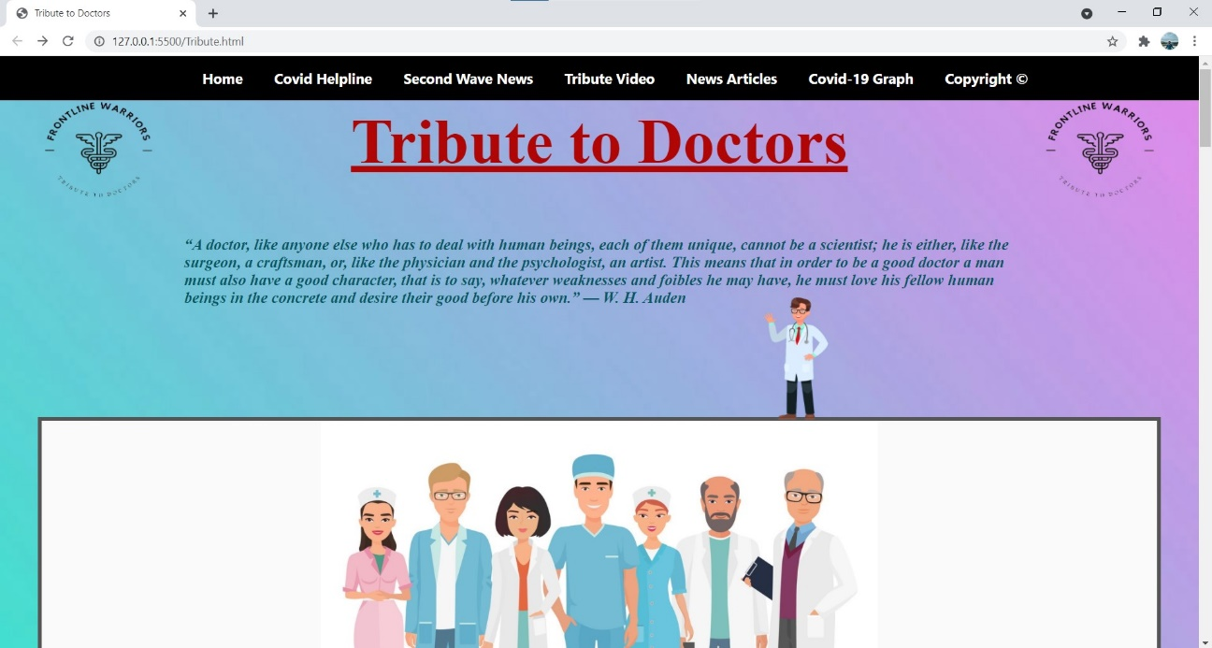

**blockquote**

**Nav Bar**

**logo**

**Gif image**

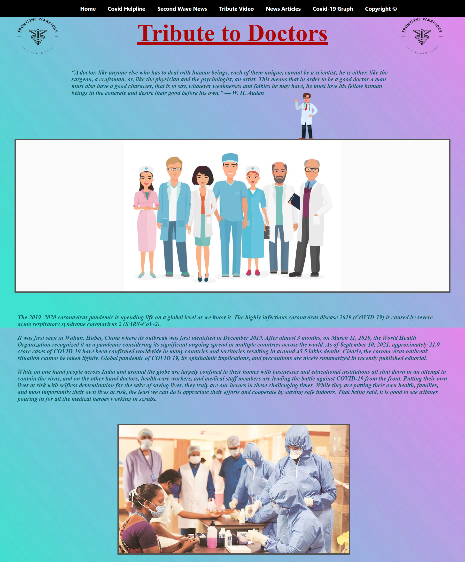

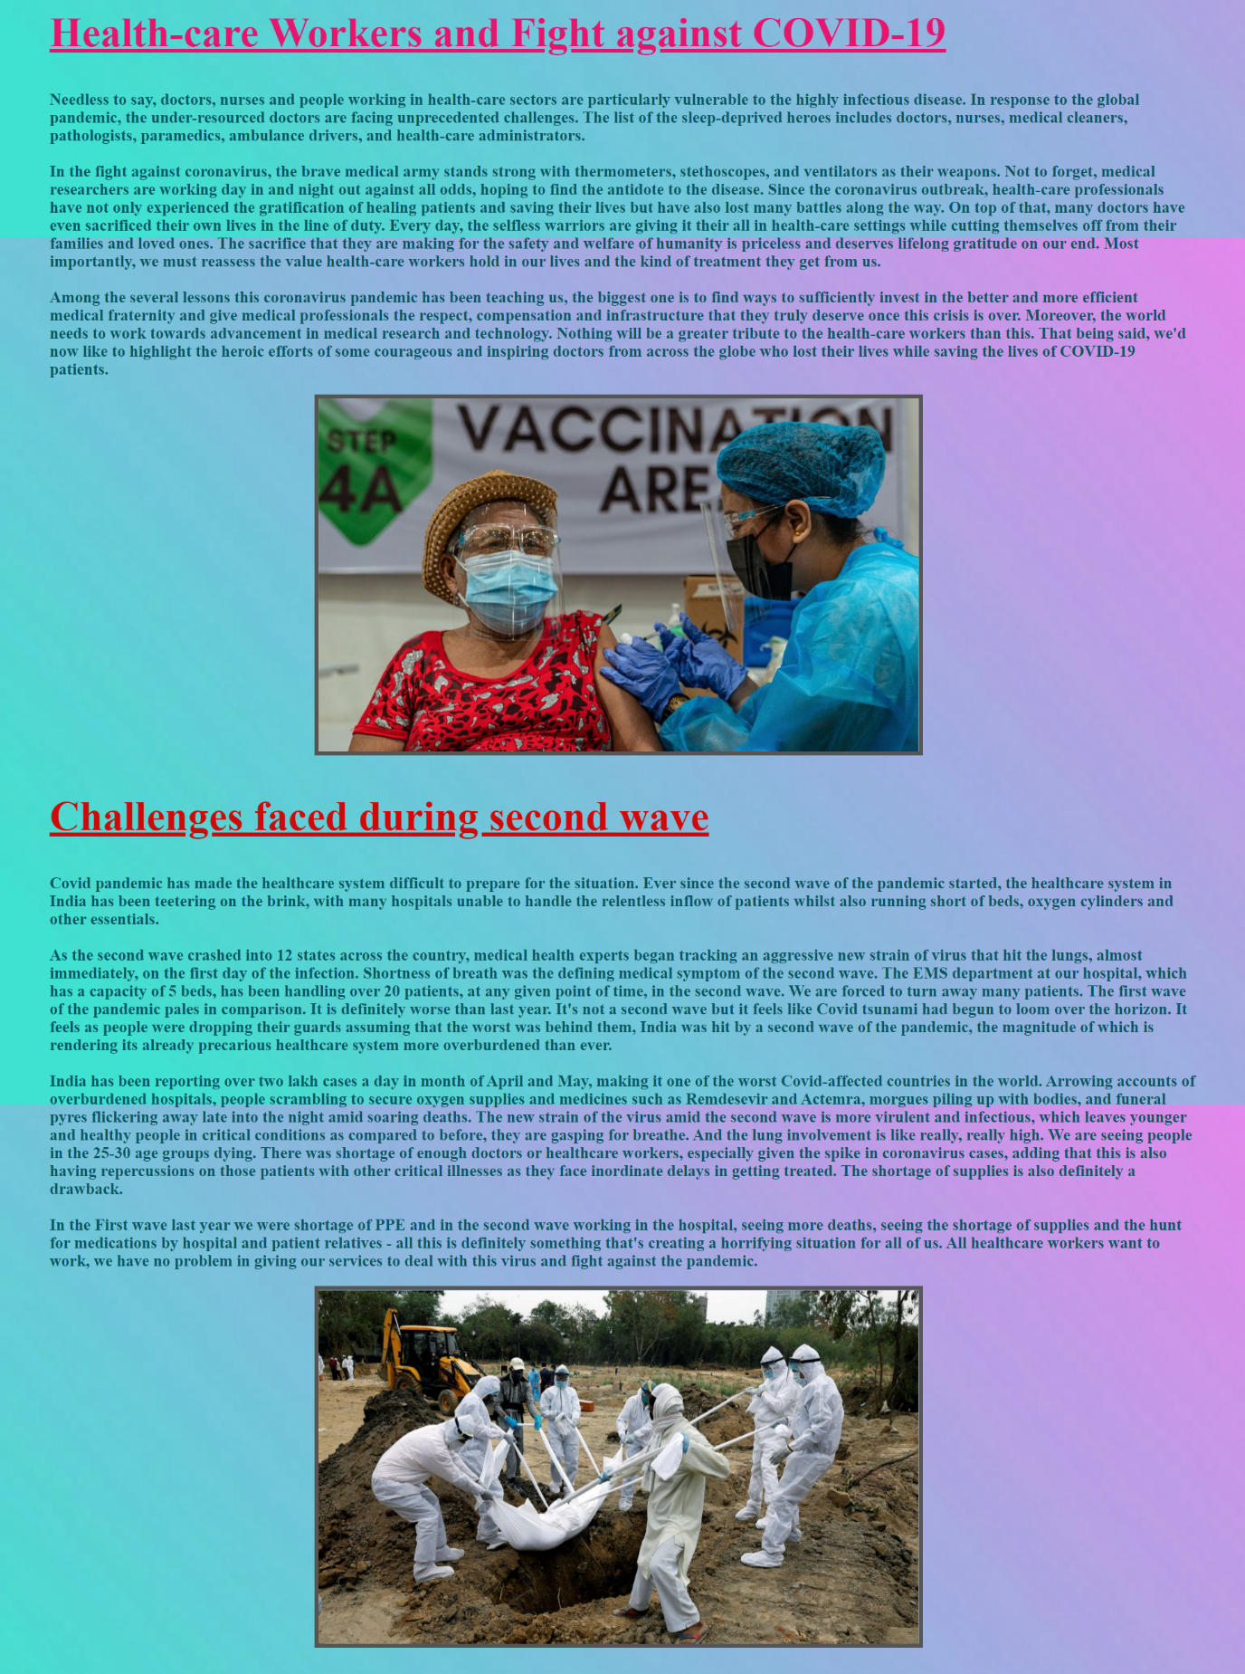

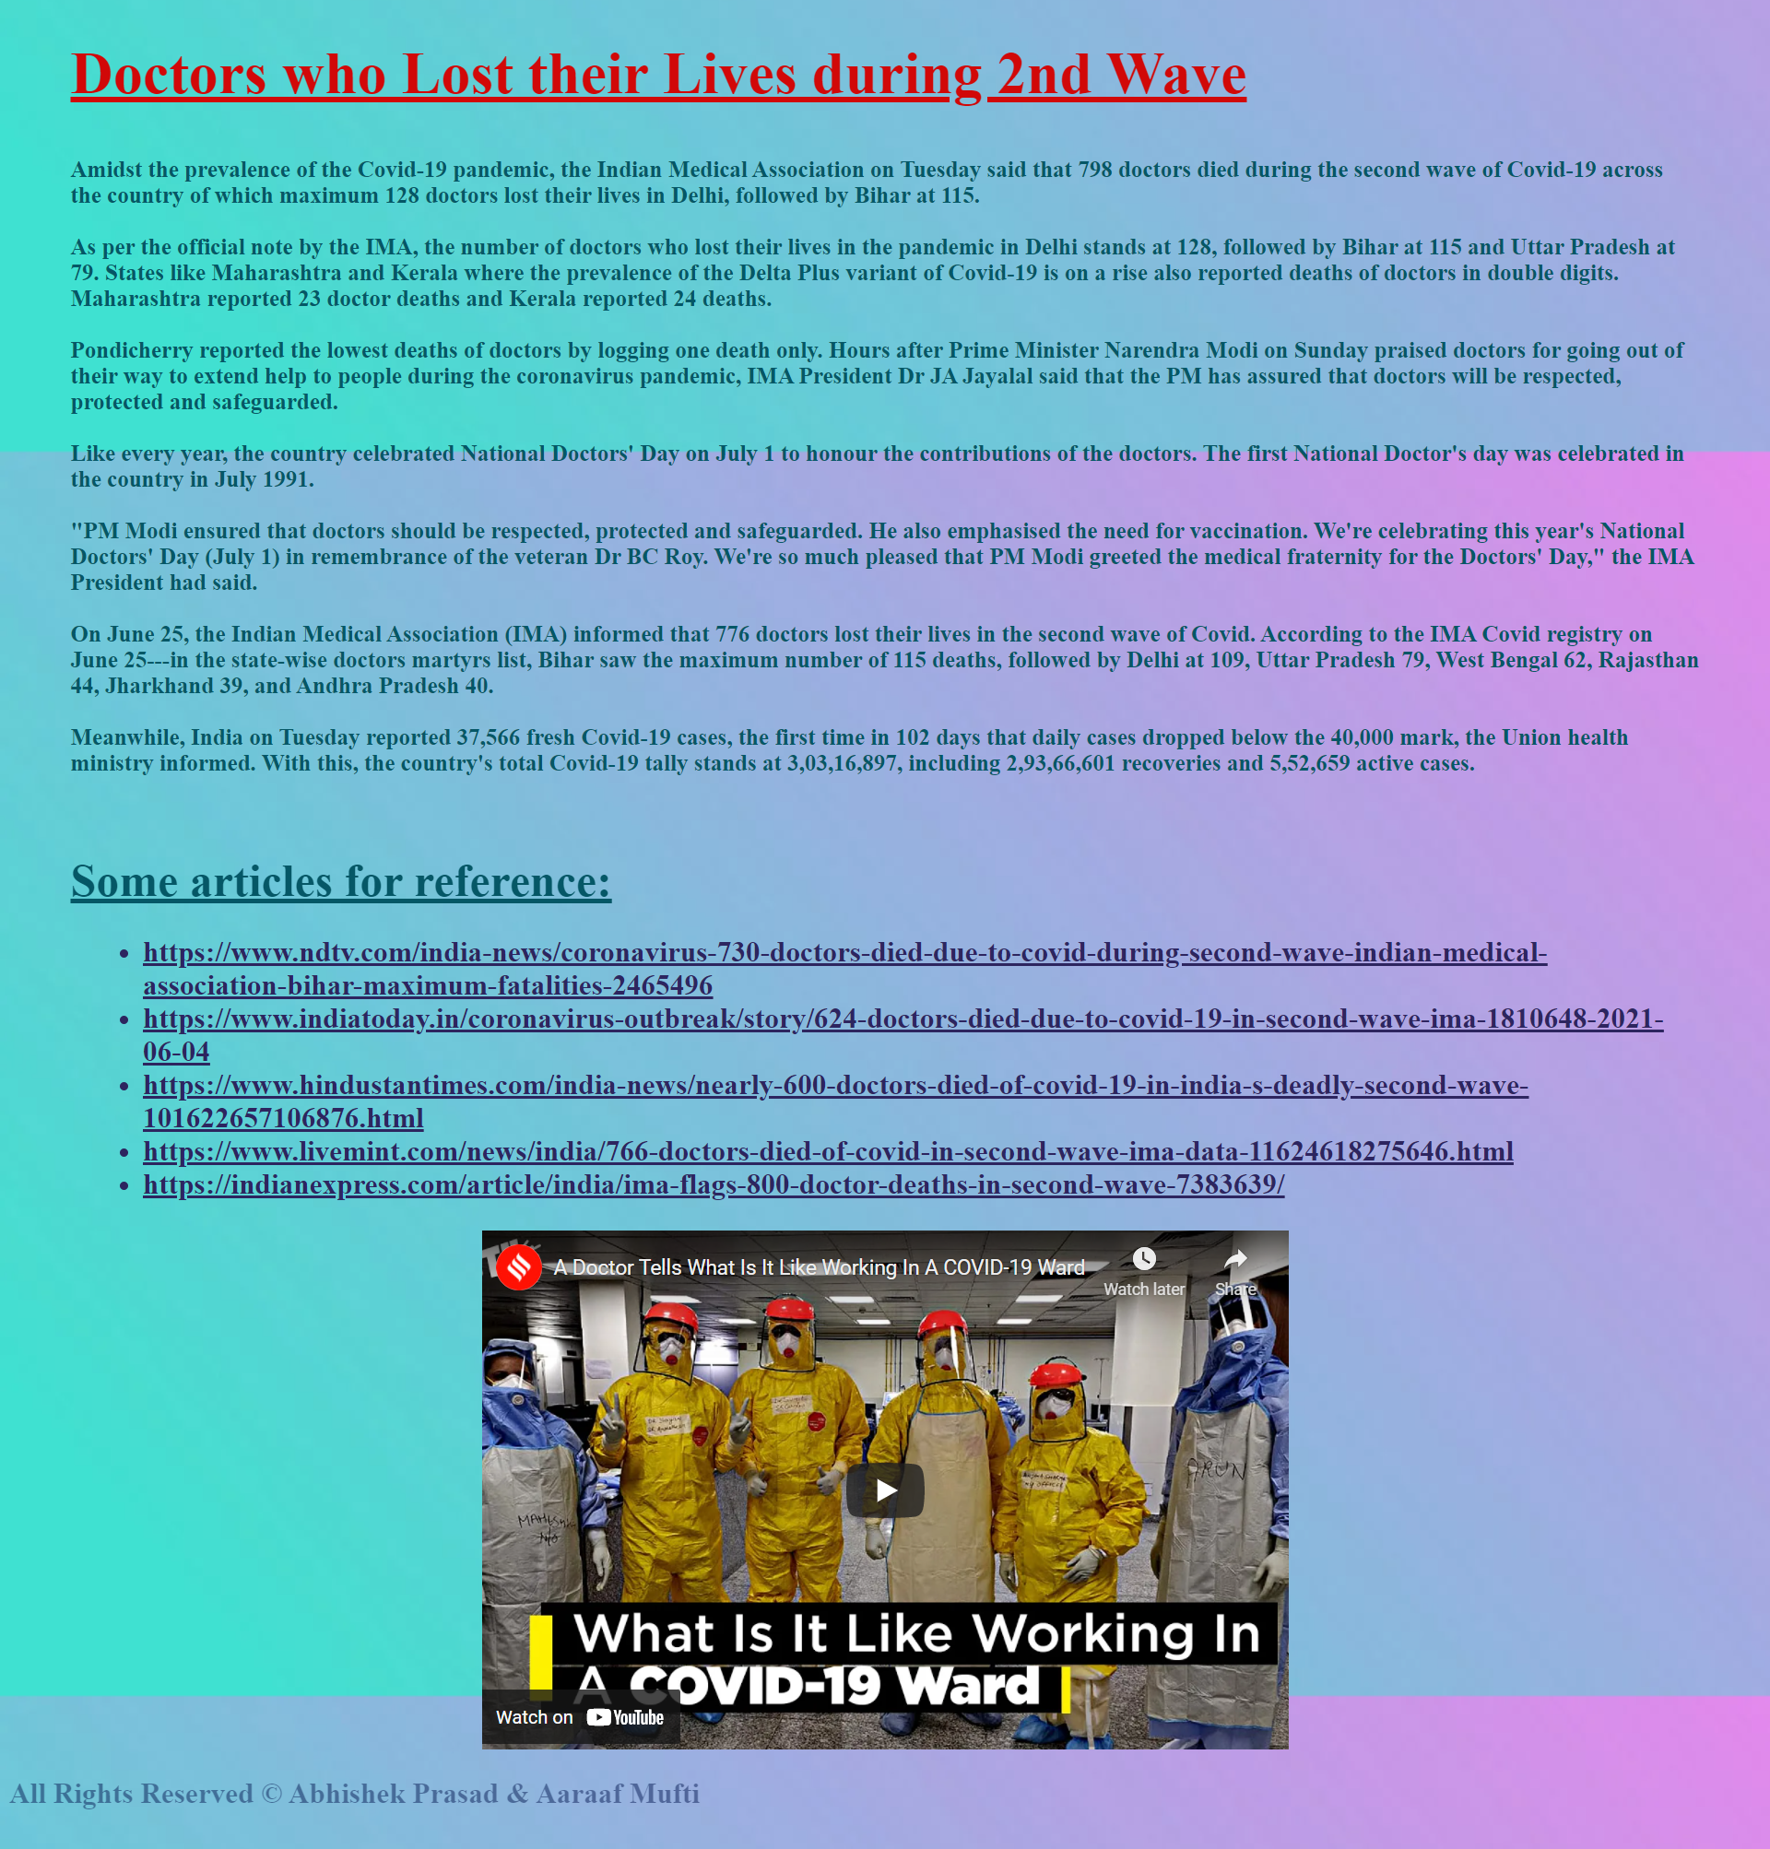

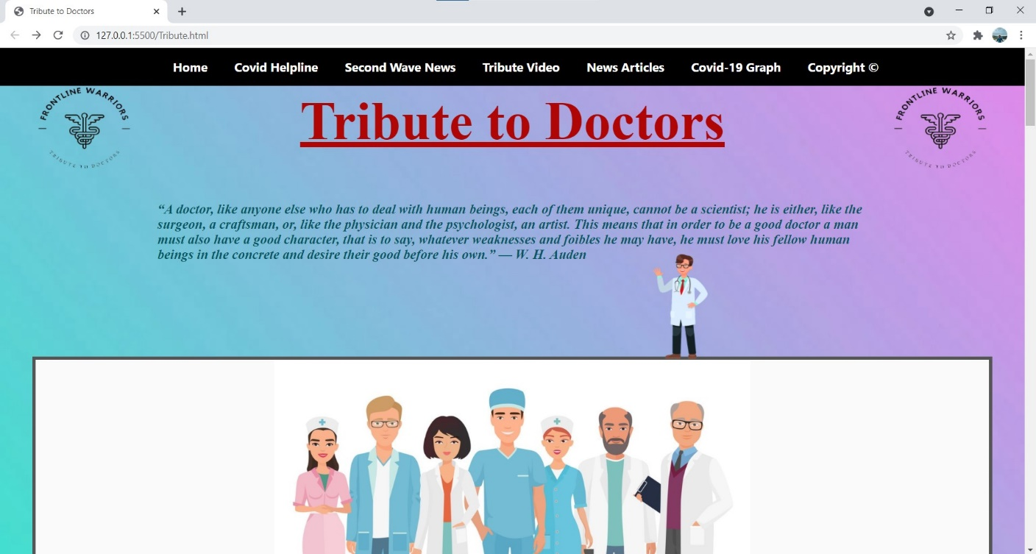

After clicking on Covid Helpline a new tab will open and the helpline number for all the states will be displayed

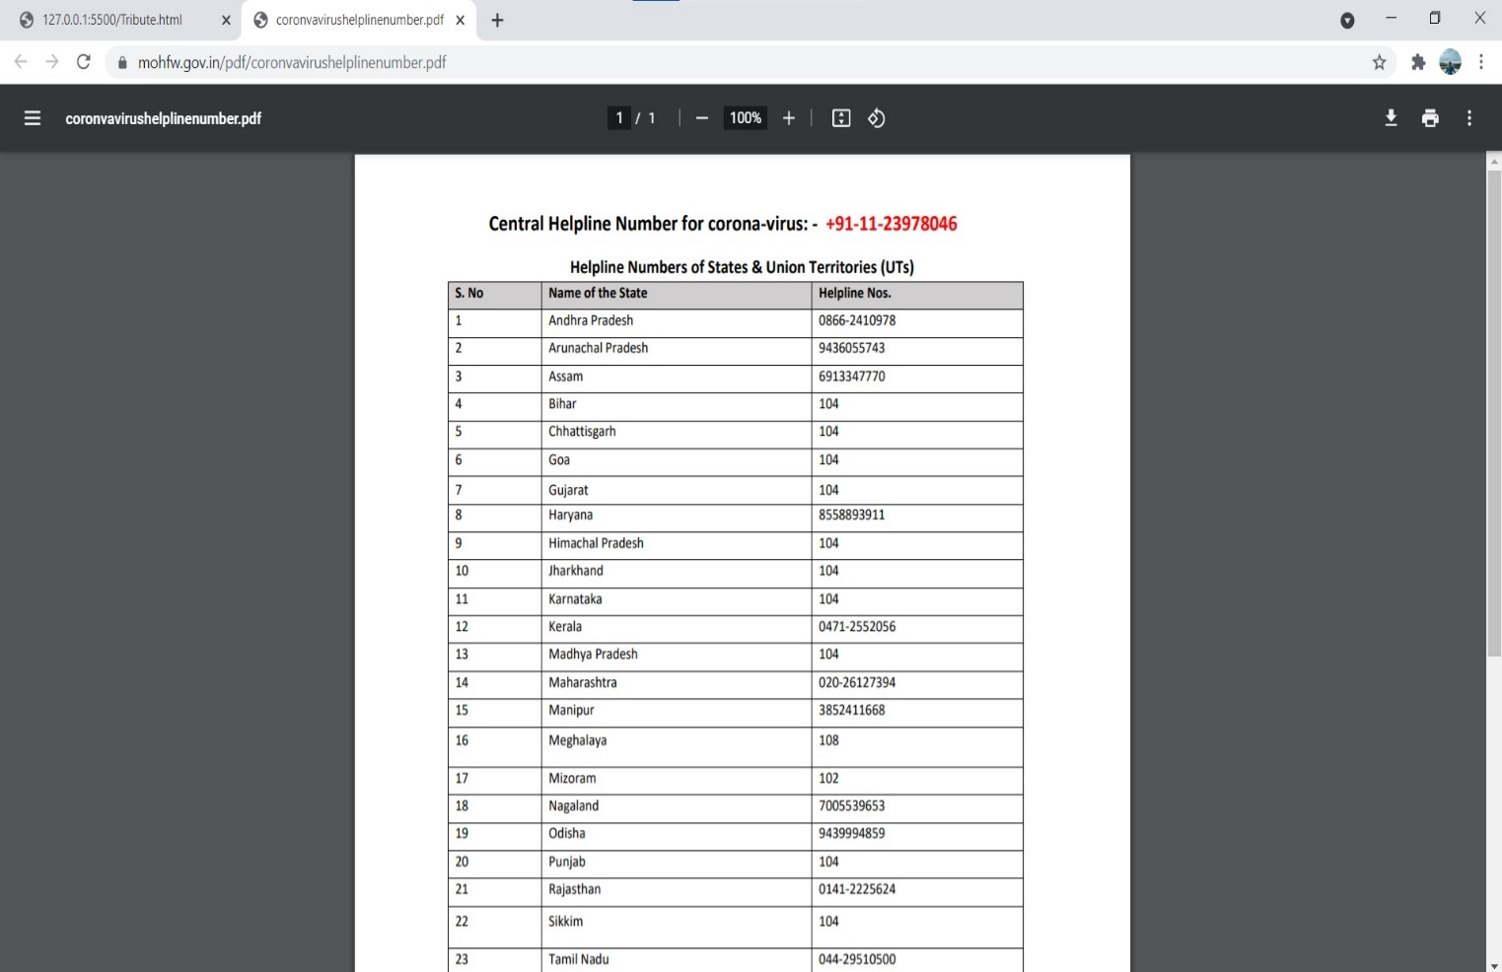



After clicking on Second Wave News all the news videos embedded link will open which is related to second wave of covid

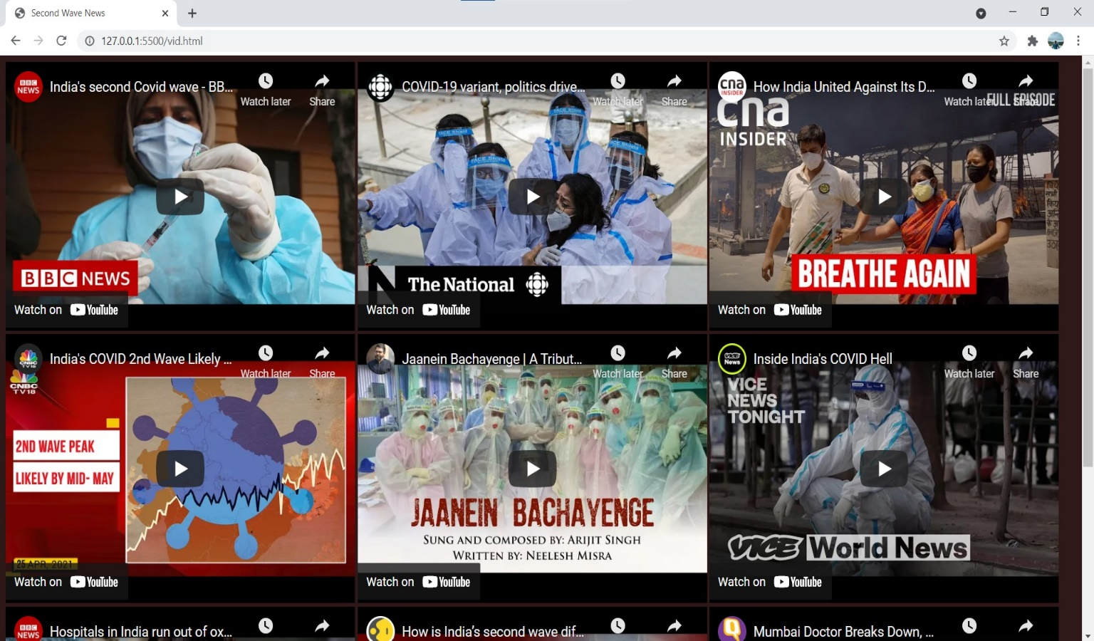



After clicking on Tribute Video a tribute music video will played for the doctors .The video player can be controlled by the user. The user can play/pause the video increase/decrease volume and also do full screen for the video.

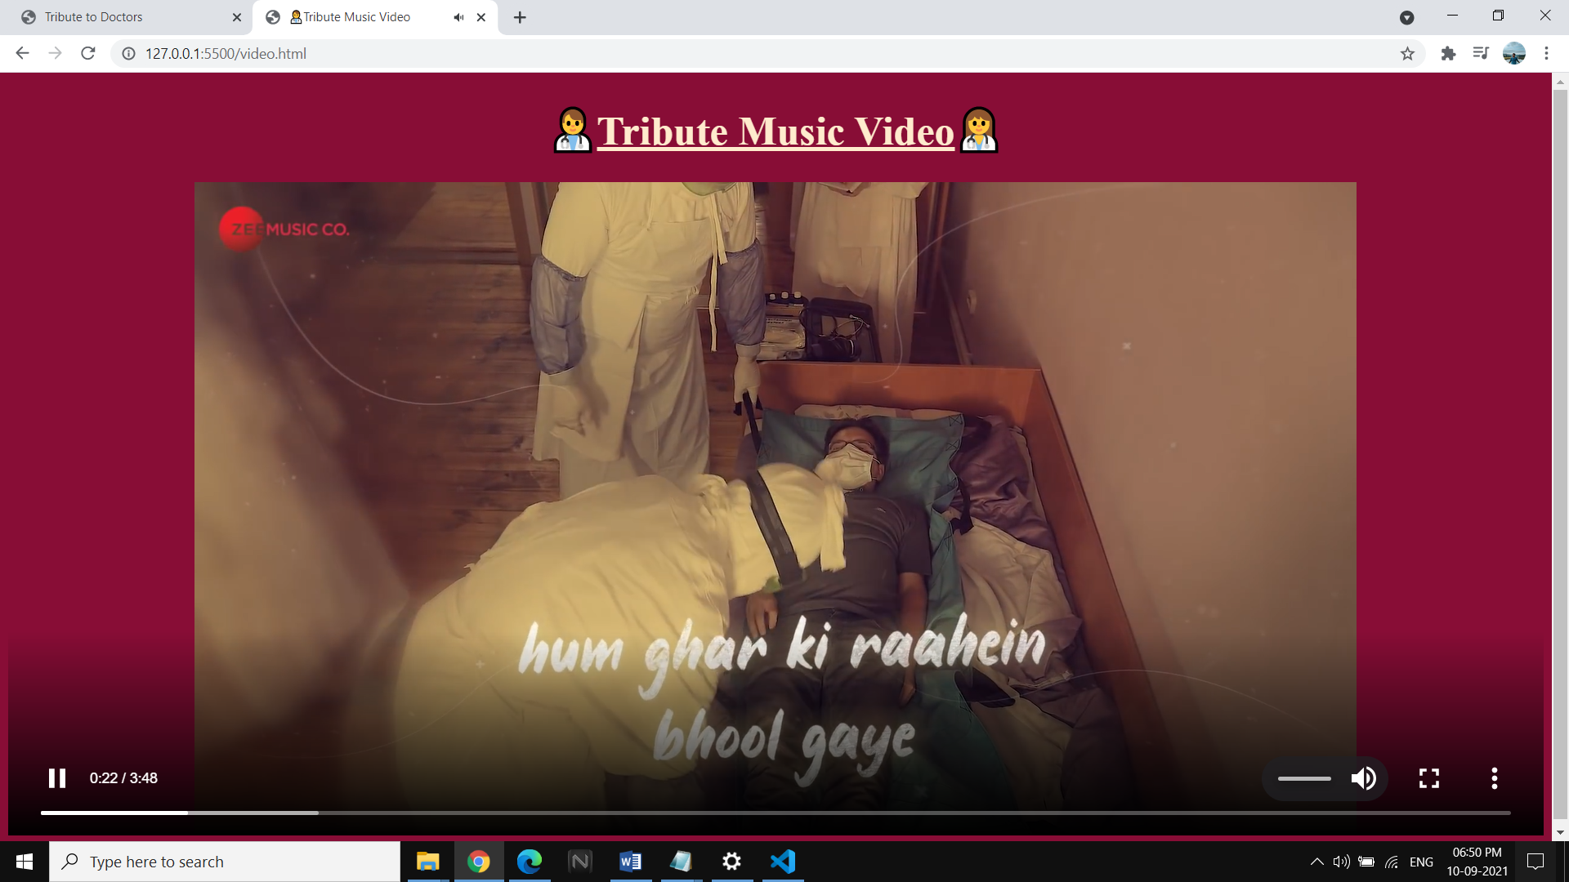

**volume control**

**play/pause**

**full screen**



After clicking on News Articles a new tab will open and all the news articles of different news media is shown. There is a hover option on the text will will open the article page.

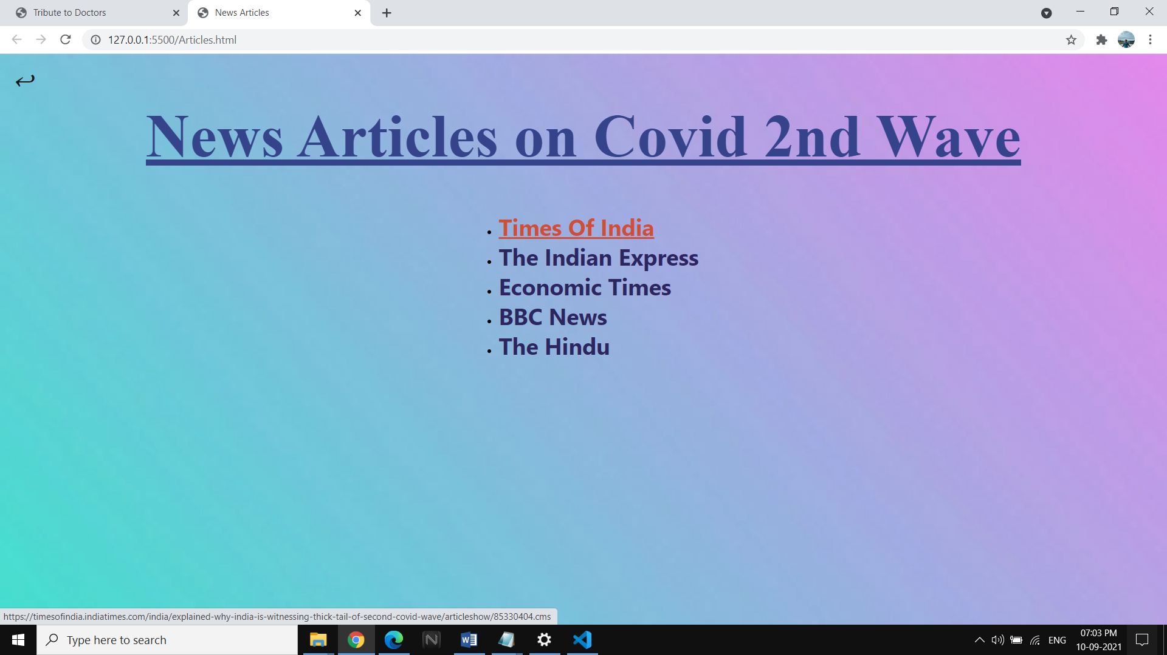

Back button to go to main page

hover link



After clicking on Covid-19 Graph a website will open where th user can see the number of covid cases till date and the current number of cases with graph of different countries, The number of deaths and recoveries is also shown.

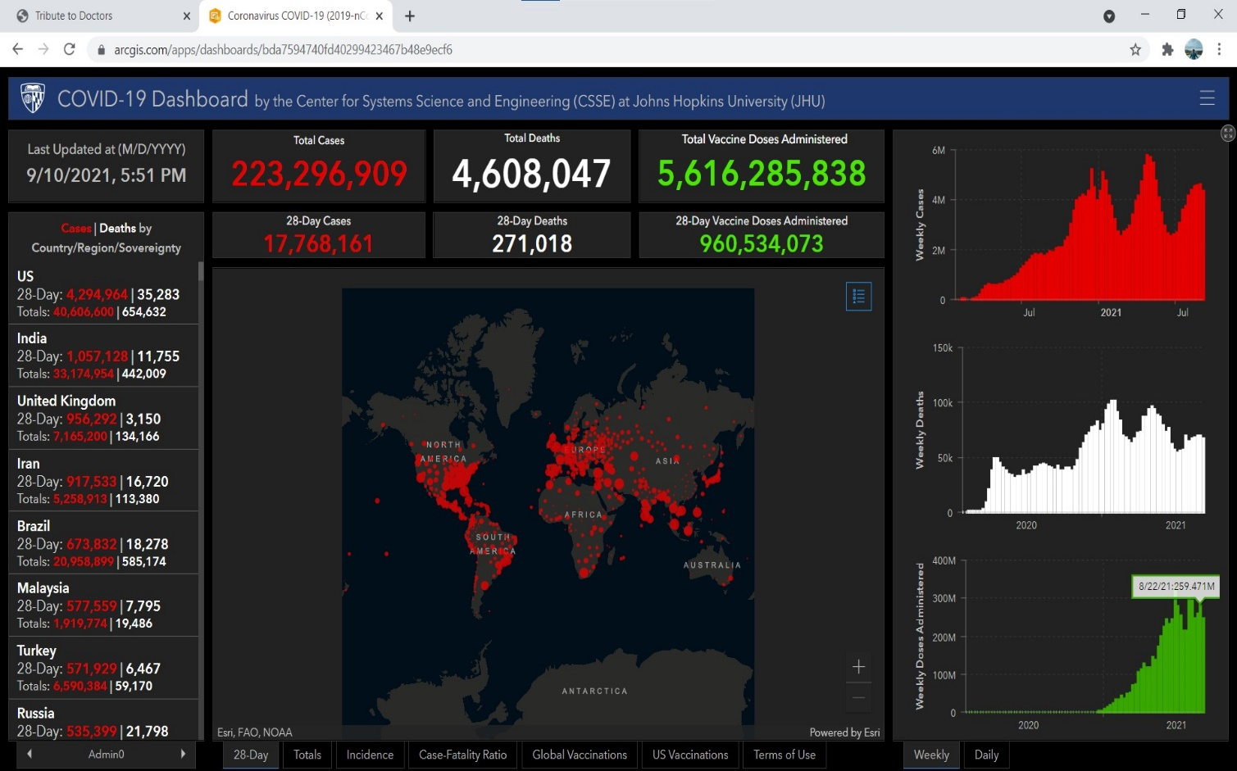



After clicking on the copyright it will show the information of the developers of this website.

**BIBLIOGRAPHY**

* https://[www.w3schools.com](http://www.w3schools.com/)
* https://[www.geeksforgeeks.org](http://www.geeksforgeeks.org/)
* <https://freefrontend.com>
* <https://en.wikipedia.org>

## About my TEAM

The name of our team is **ab**

**Team leader**- Abhishek Prasad 1AY18IS006

Created the landing page inserted the images embedded the videos, created a video player page ,the copyright page.